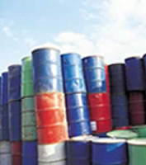
Trade Waste Officers Report 2012

Officer Name: [TEXT]

Council: [TEXT]

Background:
(Information about Council, Type of waste water facilities, population, location, new projects and developments, etc …)
[TEXT]

Trade Waste (large wet Industries)

Good stuff
[TEXT]

Challenging Issues
[TEXT]

Solutions/Ideas
[TEXT]

Grease Trap

Good stuff
[TEXT]

Challenging Issues
[TEXT]

Solutions/Ideas
[TEXT]

Interceptors

Good Stuff
[TEXT]

Challenging Issues
[TEXT]

Solutions/Ideas
[TEXT]

Storm Water
[TEXT]

Good Stuff
[TEXT]

Challenging Issues
[TEXT]

Solutions/Ideas
[TEXT]

Other Issues:
[TEXT]

Issues that need discussing at conference:
[TEXT]

