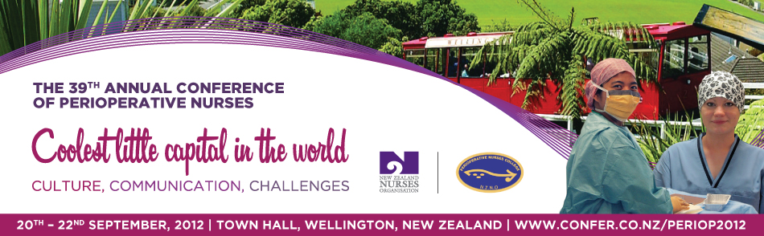

To: <department manager name>
From: <your name>
Date: <insert date>
Subject: Proposal to attend The 39th Annual Conference of Perioperative Nurses –
‘Coolest little Capital – Culture. Communication. Challenges’

Dear <Insert Department Manager’s Name>,

I would like to draw your attention to and seek your support in attending the Annual Conference of Perioperative Nurses which is taking place from the 20th – 22nd September in Wellington.

Our conference is titled “Coolest Little Capital in the World” with three broad themes: Culture, Communication and Challenges. These themes offer key challenges for all Perioperative Nurses.

We are aware of the issues facing our current and future workforce whether working in Theatres, PACU, MINZ or Aesthetics. The conference committee has worked hard to provide an opportunity to build, reinforce and refocus relationships.

The programme for this two and a half day event features an agenda of educational sessions, industry information, and the opportunity for sharing best practice.

Here are three ways that I will specifically benefit from attending the Annual Conference of Perioperative Nurses:

- Educational Sessions. This conference enables me to attend a number of sessions presented by Keynote Speakers who are experts drawn from New Zealand and Australia who will provide delegates with a diversity of material to support us in facing issues around the conference theme: ‘Culture, Communication and Challenges’ that we deal with every day.

The conference programme can be found on the website www.confer.co.nz/periop2012

These sessions provide an excellent opportunity to share knowledge with colleagues around the country and will give me the opportunity to bring new ideas back to our hospital.

- Local and International Networking Opportunities. The PNC conference will put me face-to-face with colleagues nationally. The conference networking events will provide me the opportunity to share and exchange best practices.

- Meet with Industry Suppliers/Product Managers. My time in Wellington will give me opportunities to meet with product and marketing managers with whom I can share our ideas and areas of need, as well as request enhancements to improve the products we use.

I am seeking <your hospital name here> support to attend the conference. I believe this unique professional development opportunity will be money well spent.

Here is an approximate breakdown of conference costs:

Conference Registration Fees:: $475 member/$525 non member until the 20th July. After this date, the fee is $525 member/$575 non member /Day Registration Member $250/Day Reigstration Non Member $300
+
Travel Expenses: <add flight expenses>
+
Hotel: $<select hotel and insert cost> (for ?? nights including GST and breakfast; the hotel rate for the conference is $<insert cost> per night)
+
Meals: <add meal expenses> the PNC provides most of my meals during the event including lunch for 2 days and dinner for 1 evening. In addition I will need to pay for dinner on Thursday 20th September and potentially a few additional meal expenses that I will incur while travelling.

= The total cost estimate is: <add your estimated figure>

When I return from the conference, I will submit details summarising key information and I learned with follow-up action items based on the knowledge I gained during the Annual Conference of Perioperative Nurses.

I am also happy to share the conference materials with other team members and can give brief presentations to other groups who will benefit from this knowledge. This is an ideal way for the rest of our department to benefit from my training.

I look forward to your reply.

Sincerely,

<insert your name here>

